**Scotland 2017**

November 10th-15th

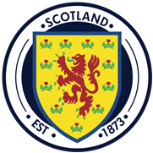

Price includes:

Air on Aer Lingus from Bradley via Dublin.  There will only be 2 busses and 1 group will fly into Glasgow from Dublin and the other into Edinburgh.  Both will be picked up and enjoy a half day city tour of Edinburgh with entrance to the castle, then we all check into our hotel in Edinburgh.  It will be the Apex Grassmarket Hotel with breakfast daily. Dinner with a bagpiper will be included one night and also a full day tour to Loch Ness and the Highlands of Scotland.  This will allow for 2 full free days. Gratuities are included.

*Insurance is additional at $115.00*.

This is going to sell out very quickly and I cannot get any more space on the air or on the bus.

Budapest, Hungary

November 5th-10th, 2015

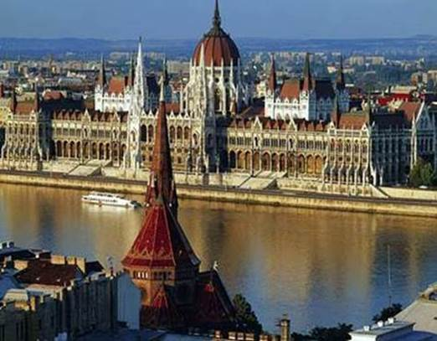

Here is what is included and the itinerary:

**11/5 Thursday:**  Bus departs PVT to Boston

50 people fly on Swiss Airlines & 50 people fly on Lufthansa

Both have to make a change of planes and then fly to Budapest.

**11/6 Friday:**  Arrive Budapest, transfer to hotel mid-day or afternoon. Evening is free.

**11/7 Saturday:**  Free to explore the city or beyond.  A group **dinner** and folklore show.

**11/8 Sunday:** A full day tour to include the Fisherman’s Bastion, view monuments on Castle Hill, **lunch,** entrance to Mathias Church and a 1 hour charter cruise on the Danube river.

**11/9 Monday:** Full day tour to include Visegrad and entrance to the Citadel near former Royal Palace & ruins, **lunch**, and the Danube bend.

**Dinner** is also included in the evening at a local restaurant.

**11/10 Tuesday**:   Breakfast and then transfer to the airport for return flight home

2014

|  |
| --- |
| MC900433600[1] |
|  |
| |  | | --- | | To reserve your spot on this trip please email Shelley at  Pioneer Valley Travel as soon as possible as this trip is expected to sell out quickly.  Priority is given to past guests of this group.  We will need a **check** for $250.00 for deposit.  Balance will be due the end of August. | |

2013